Indian Ocean Dipole
From Wikipedia, the free encyclopedia
The Indian Ocean Dipole (IOD), also known as the Indian Niño, is an irregular oscillation of sea-surface temperatures in which the western Indian Ocean becomes alternately warmer and then colder than the eastern part of the ocean
The IOD involves an aperiodic oscillation of sea-surface temperatures, between "positive", "neutral" and "negative" phases. A positive phase sees greater-than-average sea-surface temperatures and greater precipitation in the western Indian Ocean region, with a corresponding cooling of waters in the eastern Indian Ocean—which tends to cause droughts in adjacent land areas of Indonesia andAustralia. The negative phase of the IOD brings about the opposite conditions, with warmer water and greater precipitation in the eastern Indian Ocean, and cooler and drier conditions in the west.
The IOD also affects the strength of monsoons over the Indian subcontinent. A significant positive IOD occurred in 1997–98, with another in 2006. The IOD is one aspect of the general cycle of global climate, interacting with similar phenomena like the El Niño-Southern Oscillation (ENSO) in the Pacific Ocean.
The IOD phenomenon was first identified by climate researchers in 1999.^{[1][2]} Yet evidence from fossil coral reefs demonstrates that the IOD has functioned since at least the middle of the Holocene period, 6500 years ago.
An average of four each positive-negative IOD events occur during each 30-year period with each event lasting around six months. However, there have been 12 positive IODs since 1980 and no negative events from 1992 until a strong negative event in late 2010. The occurrence of consecutive positive IOD events is extremely rare with only two such events recorded, 1913–1914 and the three consecutive events from 2006 to 2008 which preceded the Black Saturday bushfires. Modelling suggests that consecutive positive events could be expected to occur twice over a 1,000-year period. The positive IOD in 2007 evolved together with La Niña, which is a very rare phenomenon that has happened only once in the available historical records (in 1967).^{[3][4][5][6]} A strong negative IOD developed in October 2010,^{[7]} which, coupled with a strong and concurrent La Niña, caused the 2010–2011 Queensland floods and the 2011 Victorian floods.
In 2008, Nerilie Abram used coral records from the eastern and western Indian Ocean to construct a coral Dipole Mode Index extending back to 1846 AD.^{[8]} This extended perspective on IOD behaviour suggested that positive IOD events increased in strength and frequency during the 20th century.^{[9]}
http://www.jamstec.go.jp/frsgc/research/d1/iod/e/iod/about_iod.html
The Indian Ocean Dipole (IOD) is a coupled ocean-atmosphere phenomenon in the Indian Ocean. It is normally characterized by anomalous cooling of SST in the south eastern equatorial Indian Ocean and anomalous warming of SST in the western equatorial Indian Ocean. Associated with these changes the normal convection situated over the eastern Indian Ocean warm pool shifts to the west and brings heavy rainfall over the east Africa and severe droughts/forest fires over the Indonesian region.

Schematic of a positive IOD event. | Schematic of a negative IOD event.
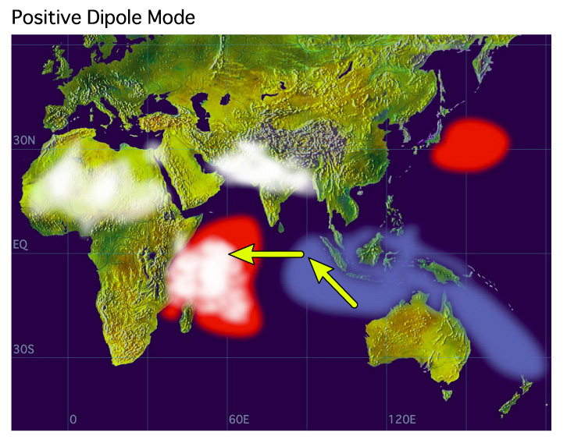 | 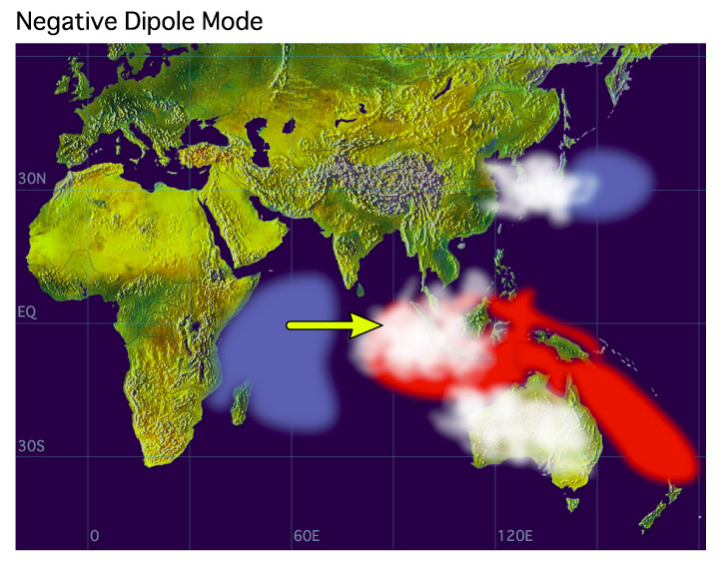
SST anomalies are shaded (red color is for warm anomalies and blue is for cold). White patches indicate increased convective activities and arrows indicate anomalous wind directions during IOD events.
The name " Indian Ocean Dipole (IOD) " was coined by Prof. Yamagata, Dr. Saji and other researchers of the Climate Variations Research Program (CVRP) of Frontier Research Center for Global Change (FRCGC) to represent the zonal dipole structure of the various coupled ocean-atmosphere parameters such as SST, OLR and Sea Surface Height anomalies. Generally, this configuration is also called positive IOD. Infact, a negative IOD also evolves preceding/following a positive IOD, with reverse in the configuration of the positive IOD.
Intensity of the IOD is represented by anomalous SST gradient between the western equatorial Indian Ocean (50E-70E and 10S-10N) and the south eastern equatorial Indian Ocean (90E-110E and 10S-0N). This gradient is named as Dipole Mode Index (DMI). When the DMI is positive then, the phenomenon is refereed as the positive IOD and when it is negative, it is refereed as negative IOD.
Since IOD is a coupled ocean-atmosphere phenomenon, it can also be represented by any other atmospheric (pressure, OLR) or oceanographic (sea surface height) as well.
SST DMI dataset (monthly from 1870 to present) derived from HadISST dataset
SST DMI dataset (weekly from Nov. 1981 to present) derived from NOAA OISST Ver.2 (base period 1971-2000)

